Url for downloading Python onto your Windows PC :

<https://www.python.org/downloads/>

This download page will appear. Click on Download Python xxxx.xxx Button to download

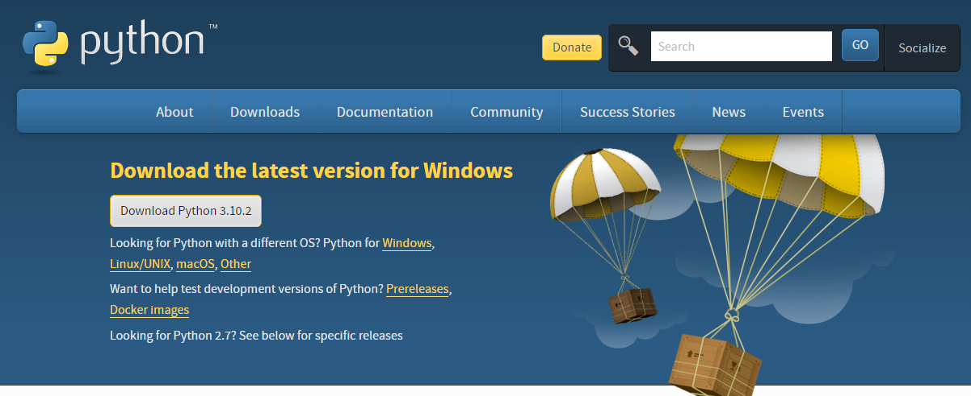

You will see this on the left bottom corner of your screen. Wait for the download to complete

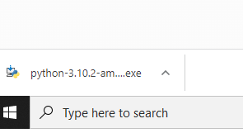

Go to your Downloads Folder. Double click it to install.

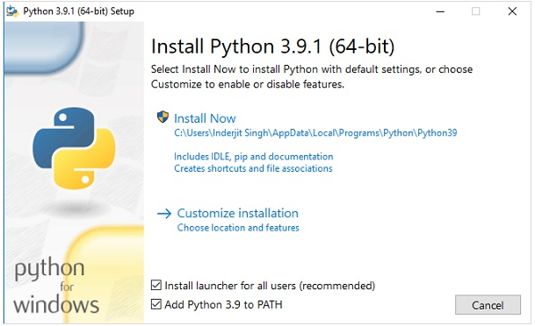

Check Install launcher and Add Python xx.xx to Path checkbox, like above

Click Install Now after that.

Python will now be installed to your PC

You can also refer to this link for more information

<https://www.tutorialspoint.com/how-to-install-python-in-windows>